RIVER TORRENS FOOTBRIDGE
INVITATION TO TENDER

Project description
The Government of South Australia require tenders for the proposed footbridge at the River Torrens precinct. This footbridge will form a connection between the Adelaide Railway Station and the newly developed Adelaide Oval to allow pedestrians easier access to the entertainment hub.
Design Requirements
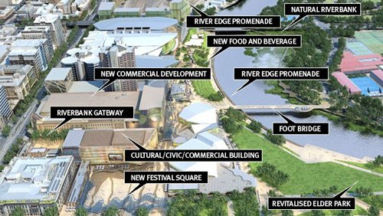
The design brief is based on the world-class SAHMRI building in the River Torrens precinct. This building was inspired by the skin of the pine cone and uses a triangulated façade to respond to the environment and provide unique shade. The Government of South Australia are keen to include a series of right-angled triangles in the design. The could be included in the bridge base, sides, rails or even a canopy. There must be at least 30 different sized right-angled triangles included in the design.
Specifications
The footbridge will need to span at least 40 metres and be approximately 8 metres wide. Applications must be on one A3 poster and include:
- Title
- Scale Plan (1:100)
- Scale Side Elevation (1:100)
Budget
The tender must include a document that addresses the cost of the steel for the bridge. All calculations for the length of steel required should be included in this document. The costings should be based on the current price of steel beams ($55 per metre).
Schedule
The tender must be submitted by ________________________________________.
Assessment
The submissions will be assessed using the following criteria:
Design | The bridge includes 30 or more different sized right-angled triangles and is accurately drawn to scale (1:100). The design meets the size specifications (spanning at least 40m and 8m wide). | /5
Calculations | All calculations for the length of steel required are included and completed accurately. The calculations clearly show the amount of steel required and the cost of this steel. Pythagoras is used to accurately calculate lengths of unknown sides in right-angled triangles. | /10

