Name:______________________________________

Biotechnology: DNA Extraction and Electrophoresis
Go to http://learn.genetics.utah.edu/content/labs/
You will be doing the DNA extraction and the Gel Electrophoresis. Complete this worksheet as you walk through the steps of the labs.

DNA Extraction

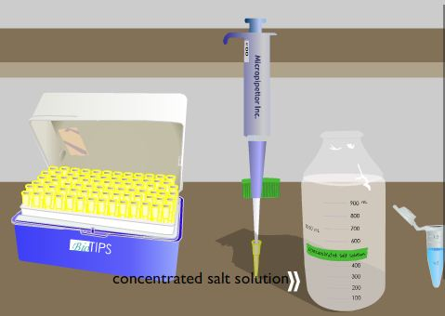
1. List three reasons for extracting DNA from a human subject:
1) ________________________________________________________
2) _________________________________________________________
3) __________________________________________________________
2. Where is DNA found in the cell? _____________________
3. From where do we obtain the cells of our test subject? ___________________________
4. List the four steps needed to extract DNA:
1) ________________________________________________________
2) _________________________________________________________
3)__________________________________________________________
4) __________________________________________________________
5. The lysis solution contains detergent, what will this do to the cell? ________________________________
It also contains proteinase K, what does this do to the cell? ________________________________________
6. What does the salt do to the cellular mixture? _________________________________
7. Why do you need to place a second tube into the centrifuge? ______________________________
After the tube is removed from the centrifuge, what equipment is used to remove the top liquid from the tube? _____________________________________________
What is in this liquid? ____________________________________
8. Isopropyl alcohol causes DNA to do what? _________________________________

Gel Electrophoresis
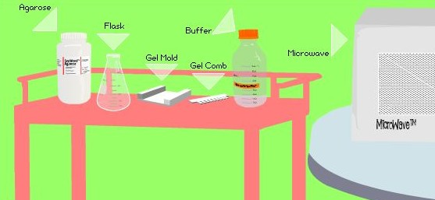
1. Gel electrophoresis is used to sort DNA strands according to their __________________
Where do you place the DNA samples on the gel? _______________________________
What makes the DNA move? _____________________
Short strands move [ faster / slower ] than longer strands.
2. Place the steps in the correct order (number them)
______ Load DNA sample into the gel
______ Stain the Gel and analyze results
______ Make the gel
______ Hook up the electrical current
______ Set up gel apparatus
3. In the "Gel Electrophoresis Laboratory", follow the steps to make your own gel, answer the questions as you go.
a) What is agarose made from? ___________________________________
b) Melted agarose is poured into a ___________________________________
c) What is the purpose of the comb? ___________________________________________
d) The black end generates a ______________ charge, the red end a _______________ charge.
e) The bubbles in the electrophoresis indicate what? _________________________________
f) Staining the DNA will make it show up under a ____________________________________ light.
g) What are your estimates for the number of base pairs in the three bands? ___________________

